CS 255 Business Requirements Document

System Components and Design

Purpose
What is the purpose of this project? Who is the client and what do they want their system to be able to do?
- The purpose of this project is to design and document a complete system for DriverPass, a company that provides driver‑training services.
- DriverPass wants a system that improves student success on DMV driving tests by offering online classes, practice exams, and scheduled on‑the‑road training.
- The system must allow customers to register, log in, schedule lessons, take practice tests, and track their progress.
- The client wants the system to be accessible from any device, with cloud‑based hosting and minimal technical overhead.
- The system must support multiple user roles (owner, IT officer, secretary, drivers, customers) with different permissions and responsibilities.
- The system should allow staff to manage appointments, track user activity, and generate downloadable reports.
- The system must integrate with the DMV to receive updates on rules, policies, and sample test questions.

System Background
What does DriverPass want the system to do? What is the problem they want to fix? What are the different components needed for this system?
- DriverPass wants to solve the problem of low DMV driving‑test pass rates by providing better training tools for students.
- Many students fail because they only study old tests; DriverPass wants a system that offers structured learning, practice tests, and real driving lessons.
- The system must support online classes, practice exams, and scheduling for on‑the‑road training sessions.
- DriverPass needs a centralized, cloud‑based platform accessible from any device, allowing staff and customers to interact with the system remotely.
- The system must allow customers to register, log in, schedule lessons, modify or cancel appointments, and reset forgotten passwords.
- Staff members (secretary, drivers, IT officer, owner) need tools to manage customer information, appointments, driver assignments, and system access.
- The system must track which customer is assigned to which driver, car, date, and time for each lesson.
- The system must store and display driver notes for each lesson, including start time, end time, and comments.
- The system must track online test progress, including test name, time taken, score, and status (not taken, in progress, failed, passed).
- The system must integrate with the DMV to receive updates on rules, policies, and sample questions, and notify DriverPass when updates occur.
- The system must support report generation and allow the owner to download data for offline review (e.g., Excel).
- The system must include multiple components such as user management, scheduling, reporting, online learning modules, test tracking, and DMV integration.

Objectives and Goals
What should this system be able to do when it is completed? What measurable tasks need to be included in the system design to achieve this?
- Provide customers with access to online learning materials, including classes and practice tests.
- Allow customers to create accounts, log in, and reset forgotten passwords automatically.
- Enable customers to schedule, modify, and cancel driving lesson appointments online.
- Allow the secretary to register customers, enter their information, and schedule appointments by phone or in person.
- Track all driving lesson details, including assigned driver, car, date, time, and pickup/drop-off location.
- Record and display driver notes for each lesson, including start time, end time, and comments.
- Track online test progress, including test name, time taken, score, and status (not taken, in progress, failed, passed).
- Provide the owner with the ability to download reports and review business data offline.
- Maintain role-based access control for owner, IT officer, secretary, drivers, and customers.
- Allow the IT officer to reset employee accounts, block access, and maintain system security.
- Integrate with the DMV to receive updates on rules, policies, and sample questions, and notify DriverPass when updates occur.
- Provide a cloud-hosted, web-based platform accessible from any computer or mobile device.
- Maintain an activity log showing who created, modified, or canceled reservations, and allow printing of activity reports.
- Allow the owner to disable training packages so customers can no longer register for them.

Requirements

Nonfunctional Requirements
In this section, you will detail the different nonfunctional requirements for the DriverPass system. You will need to think about the different things that the system needs to function properly.

Performance Requirements
What environments (web-based, application, etc.) does this system need to run in? How fast should the system run? How often should the system be updated?
- The system must run as a web‑based, cloud‑hosted application accessible through standard browsers.
- The system should support access from any computer or mobile device with an internet connection.
- Pages should load quickly, with typical operations (login, scheduling, test access) completing within 2–3 seconds under normal load.
- The system must support multiple concurrent users without performance degradation, including customers, staff, and administrators.
- The system should maintain high availability, with minimal downtime, since customers may access it at any time.
- Updates to DMV rules, policies, and sample questions must be processed as soon as they are received from the DMV.
- System updates, patches, and maintenance should be handled by the cloud provider to minimize technical burden on DriverPass staff.
- The system must allow the owner to download reports efficiently, with exports generating within a reasonable time frame.
- The scheduling system must respond in real time to prevent double‑booking of drivers, cars, or time slots.

Platform Constraints
What platforms (Windows, Unix, etc.) should the system run on? Does the back end require any tools, such as a database, to support this application?
- The system must run as a web‑based, cloud‑hosted application, not a local desktop application.
- The system should be accessible through standard web browsers on Windows, macOS, Linux, and mobile operating systems such as iOS and Android.
- The system must not require DriverPass to maintain local servers; all hosting, backups, and security should be handled by the cloud provider.
- The back end must include a centralized database to store customer information, appointments, driver assignments, test results, and activity logs.
- The database must support real‑time updates to prevent scheduling conflicts or duplicate data.
- The system must integrate with external DMV systems to receive rule and policy updates.
- The platform must support role‑based access control for different user types (owner, IT officer, secretary, drivers, customers).
- The system must support secure data exchange between the client interface and the cloud server.
- The platform should be scalable to support future growth, such as additional packages or new training modules.

Accuracy and Precision
How will you distinguish between different users? Is the input case-sensitive? When should the system inform the admin of a problem?
- The system must uniquely identify each user through a secure username and password combination.
- User roles (owner, IT officer, secretary, driver, customer) must be clearly distinguished through role‑based access control.
- All user inputs—such as names, addresses, payment information, and scheduling details—must be validated for accuracy and completeness.
- The system must prevent duplicate accounts by checking for unique identifiers such as email address or phone number.
- Input fields should enforce proper formatting (e.g., credit card number length, expiration date format, phone number format).
- The system must ensure that appointment times do not overlap for the same driver or car.
- The system must accurately track and timestamp all changes to reservations, including who created, modified, or canceled them.
- Online test results must be recorded precisely, including test name, time taken, score, and status.
- The system should notify the IT officer or owner if unusual activity occurs, such as repeated failed login attempts or suspicious account behavior.
- Password reset requests must be validated through secure identity verification to ensure accuracy.
- The system must ensure that pickup and drop‑off locations match, as required by DriverPass.

Adaptability
Can you make changes to the user (add/remove/modify) without changing code? How will the system adapt to platform updates? What type of access does the IT admin need?
- The system must allow the IT officer to add, remove, or modify user accounts without requiring code changes.
- Role‑based permissions must be configurable so the IT officer can adjust access levels as needed.
- The system should allow the owner to disable training packages without modifying the underlying code.
- The system must be able to adapt to DMV rule and policy updates, automatically incorporating new information when received.
- The cloud‑hosted platform must support updates and patches without requiring downtime or manual intervention from DriverPass staff.
- The system should be scalable to support future enhancements, such as additional training modules or new package types.
- The interface should be adaptable to different screen sizes and devices, including desktops, tablets, and mobile phones.
- The system should allow administrators to update content (e.g., contact information, class materials) through the interface rather than through code changes.
- The database structure should support future expansion, such as adding new fields or tables, without major redesign.
- The system must remain functional across browser updates and operating system updates.

Security
What is required for the user to log in? How can you secure the connection or the data exchange between the client and the server? What should happen to the account if there is a “brute force” hacking attempt? What happens if the user forgets their password?
- The system must require each user to log in with a unique username and password.
- All data exchanged between the client and server must be secured using encrypted connections (e.g., HTTPS/TLS).
- The system must implement role‑based access control, ensuring each user (owner, IT officer, secretary, driver, customer) only sees and performs actions appropriate to their role.
- The IT officer must have full administrative rights, including the ability to reset passwords, block accounts, and modify user access.
- The system must track all user actions related to reservations, including who created, modified, or canceled each appointment.
- The system must maintain an activity log that can be printed or exported for auditing purposes.
- The system must automatically lock or temporarily disable an account after repeated failed login attempts to prevent brute‑force attacks.
- Customers must be able to reset their passwords automatically through a secure identity‑verification process.
- Sensitive information such as credit card numbers must be stored securely and handled according to industry standards.
- The system must protect against unauthorized access, data redundancy, and duplicate records by enforcing online‑only data modification.
- Cloud hosting must provide built‑in security features such as backups, monitoring, and protection against data loss.

Functional Requirements
Using the information from the scenario, think about the different functions the system needs to provide. Each of your bullets should start with “The system shall . . .” For example, one functional requirement might be, “The system shall validate user credentials when logging in.”
- The system shall allow customers to create an account and log in securely.
- • The system shall allow customers to reset their passwords automatically if forgotten.
- • The system shall allow customers to schedule, modify, and cancel driving lesson appointments online.
- • The system shall allow the secretary to schedule, modify, and cancel appointments for customers by phone or in person.
- • The system shall store customer information, including name, address, phone number, state, and payment details.
- The system shall record pickup and drop‑off locations for each scheduled lesson.
- The system shall assign each lesson to a specific driver, car, date, and time.
- The system shall prevent double‑booking of drivers, cars, or time slots.
- The system shall track all changes to reservations, including who created, modified, or canceled them.
- The system shall allow the owner and IT officer to view and print activity reports.
- The system shall allow the owner to download business data and reports for offline use (e.g., Excel).
- The system shall allow the IT officer to reset employee accounts and block access when necessary.
- The system shall enforce role‑based access control for all user types.
- The system shall allow drivers to view their assigned lessons.
- The system shall allow drivers to enter lesson notes, including start time, end time, and comments.
- The system shall provide customers access to online classes and learning materials based on their purchased package.
- The system shall provide customers access to online practice tests.
- The system shall track online test progress, including test name, time taken, score, and status (not taken, in progress, failed, passed).
- The system shall allow the owner to disable training packages so customers cannot register for them.
- The system shall integrate with the DMV to receive updates on rules, policies, and sample questions.
- The system shall notify DriverPass staff when DMV updates are received.
- The system shall provide a “Contact Us” page for customers.
- The system shall allow staff to contact customers through the system.
- The system shall run as a cloud‑hosted web application accessible from any computer or mobile device.

User Interface
What are the needs of the interface? Who are the different users for this interface? What will each user need to be able to do through the interface? How will the user interact with the interface (mobile, browser, etc.)?
- The system must provide a web‑based, cloud‑hosted interface accessible through standard browsers on computers and mobile devices.
- The interface must support multiple user roles, each with different permissions and available features.
- The interface must be simple, clean, and easy to navigate for customers and staff.
- The interface must include secure login and password‑reset functionality for all users.
- The interface must provide clear navigation to online classes, practice tests, scheduling, and account information.
- The interface must display online test progress, including test name, time taken, score, and status (not taken, in progress, failed, passed).
- The interface must display driver lesson notes, including start time, end time, and driver comments.
- The interface must include a student registration form for customers and for the secretary to enter customer information.
• The interface must include a “Contact Us” page and a way for staff to contact students.
- The interface must allow the owner to view reports, download data, and access activity logs.
- The interface must allow the IT officer to manage user accounts, reset passwords, and block access.
- The interface must allow drivers to view their assigned lessons and enter lesson notes.
- The interface must allow customers to schedule, modify, and cancel appointments.
- The interface must prevent scheduling conflicts by showing available times, drivers, and cars.
- The interface must adapt to different screen sizes and devices (responsive design).

Assumptions
What things were not specifically addressed in your design above? What assumptions are you making in your design about the users or the technology they have?
- It is assumed that all users (customers, staff, drivers, owner, IT officer) have access to a reliable internet connection to use the cloud‑based system.
- It is assumed that customers have access to a computer or mobile device capable of running a modern web browser.
- It is assumed that the DMV will provide updates in a compatible digital format that the system can process.
- It is assumed that DriverPass will provide accurate and up‑to‑date information for registration, scheduling, and training packages.
- It is assumed that drivers will enter lesson notes promptly and accurately after each session.
- It is assumed that the cloud hosting provider will handle backups, security patches, and uptime.
- It is assumed that payment processing will be handled through a secure, industry‑standard service.
- It is assumed that the secretary and staff will be trained to use the system effectively.
- It is assumed that the owner will provide the final interface design sketch referenced in the interview.
- It is assumed that the system will not need to support offline data entry, except for downloaded reports.
- It is assumed that future features (such as customizable packages) are not required in the initial release.

Limitations
Any system you build will naturally have limitations. What limitations do you see in your system design? What limitations do you have as far as resources, time, budget, or technology?
- The system is limited to being a web‑based application, meaning it cannot function offline except for downloaded reports.
- DriverPass relies on cloud hosting, so uptime, backups, and security depend on the cloud provider’s reliability.
- The system depends on the DMV to provide updates in a timely and compatible format; delays or format changes may affect accuracy.
- The initial design does not include mobile apps; users must access the system through a browser.
- The project timeline is fixed, with specific deadlines for diagrams, interface design, database linking, business logic, testing, and delivery.
- The development team has limited personnel, with certain tasks dependent on specific individuals (e.g., John returning from vacation to build the class diagram).
- Budget constraints may limit advanced features, such as automated DMV data parsing or AI‑driven scheduling optimization.
- The system does not initially support multilingual interfaces or accessibility features beyond standard browser capabilities.
- The system does not include payment processing details beyond basic assumptions, which may require third‑party integration.
- Future features mentioned by the client are intentionally excluded from the initial release to stay within scope.
- The system’s performance depends on users having stable internet access; poor connectivity may affect usability.

Gantt Chart
Please include a screenshot of the GANTT chart that you created with Lucidchart. Be sure to check that it meets the plan described by the characters in the interview.

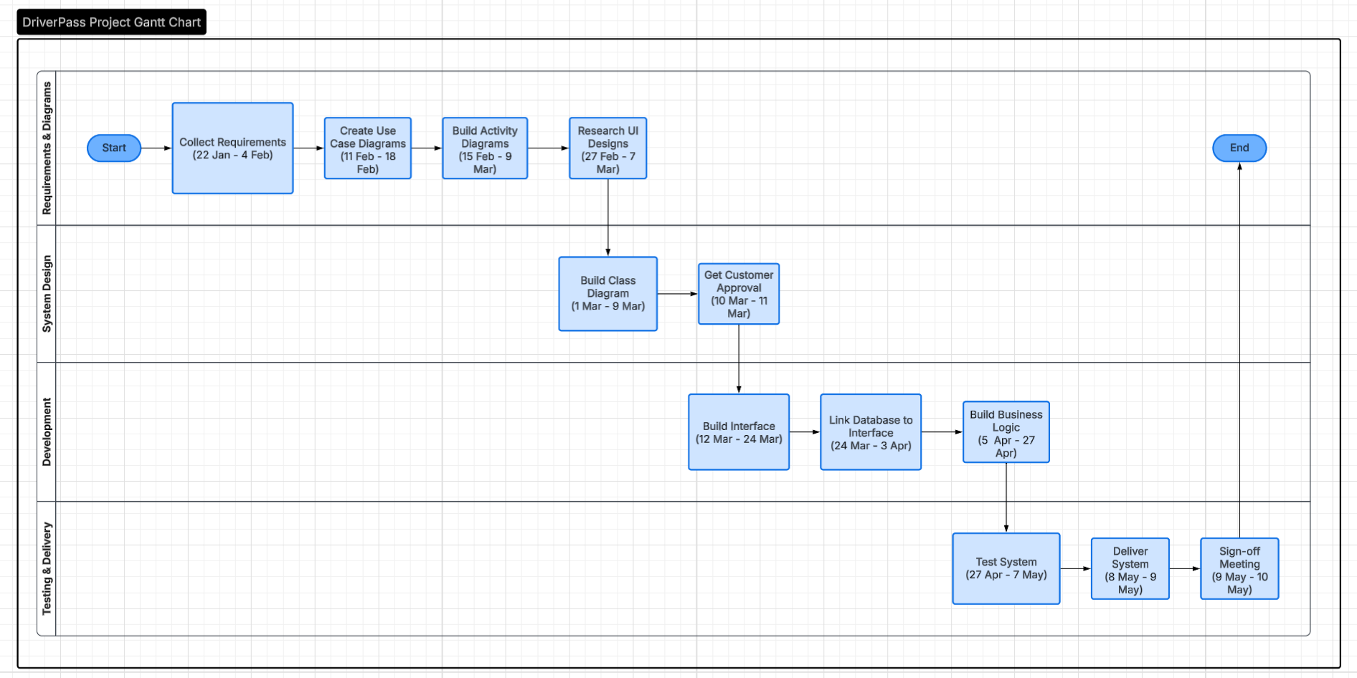
Gantt chart showing the DriverPass project schedule, including task durations, dependencies, and phase breakdowns.

